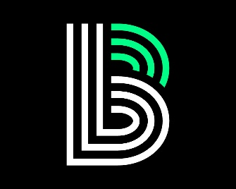
Big Brothers Big Sisters of Shelby & Darke County
121 E. North Street
P O Box 885
Sidney, OH 45365
937-492-7611
info@bigbrobigsis-shelbydarke.org

“LITTLES” SCHOLARSHIP APPLICATION
Big Brothers Big Sisters of Shelby & Darke County is accepting scholarship applications for our “Littles” to help fund participation in camps, courses, classes, and other programs which will greatly benefit the child. Scholarships are worth up to $50 each. The maximum award per child, per calendar year (Jan 1 – Dec 31) is $100. To be eligible, student must be enrolled in Big Brothers Big Sisters of Shelby & Darke County and a resident of Shelby or Darke County, Ohio. Complete one application per camp, course, class, or program; and a check will be made payable to that organization. Return completed scholarship application(s) to the address listed above.

Student Information
First Name: ____________________________________ Last Name: ____________________________________________
Address: _____________________________________________________________________________________________
Phone: ___________________________ Email: ______________________________________________________________
School Attending: _________________________________________________Grade:________________________________
How are you affiliated with BBBS: _________________________________________________________________________

Parent or Guardian Information
First Name: ____________________________________ Last Name: ____________________________________________
Address: _____________________________________________________________________________________________
Phone: ___________________________ Email: ______________________________________________________________
Relationship to Child: ___________________________________________________________________________________

Participation Information
Camp/Course/Class/Program Name: _______________________________________________________________________
Location: _______________________________ Duration: ______________________ Cost: _________________________
Scholarship to be made payable to: ________________________________________________________________________
Address: _____________________________________________________________________________________________
In your opinion, how will participation in this camp, course, class, or program benefit the child: ________________________________________________________________________________________________________________________________________________________________________________________________________________________________________________________________________________________________________________________________________________________________________________________________________________________________________________________________________________________________________________________________________________________________________________________________________________________________________________________________________________________________________________________________________________________________________________________________________________________________________

If you have any questions, please contact Jennifer Bruns
jenny@bigbrobigsis-shelbydarke.org
937-492-7611 or 937-547-9622

